September 5th, 2010
Hi
Not much to write about. On Friday my broadband connection was misbehaving again. (I had written a similar comment in the corresponding letter last year!) It would go off and on and then give an (!) icon indicating little or no connection. The company technician came yesterday but by that time it was working again!
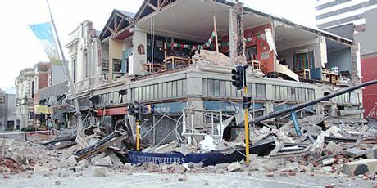
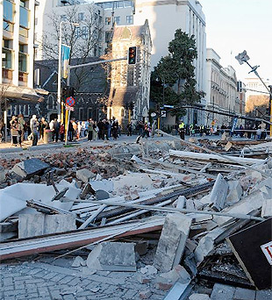
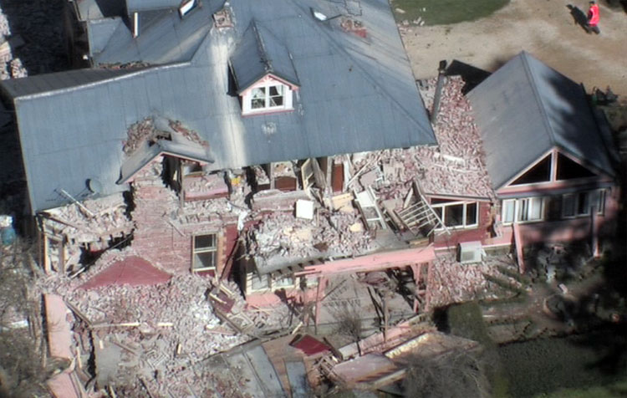
Of course, the big news, which you already know about is the 7.4 (?7.1) earthquake that hit Christchurch. It was centred 30 km west of Christchurch at Darfield and not far below ground (a bad sign of a damaging quake). You may remember Darfield – it is where Lyndsay and Lorraine Jacobs used to live and is on the main road to the West Coast (though if you take the alternative road, it by-passes Darfield). If you saw any of the pictures, you will know that there has been extensive damage in Christchurch, especially in the CBD and in older areas where there are a lot of brick buildings. A state of emergency was declared and last night there was a curfew in the centre of town. But remarkably, not one fatality has been reported; this was partly due to the quake happening at 4:30 am when few people would have been in town and also because of the very strict earthquake building code in NZ. For example, all houses must be built with a wooden framework as wood 'gives' in an earthquake. The cladding, however, can be brick or stone, as with Nana'a house. So although the cladding may fall, the house will not collapse. However, early estimates indicate that about 20 percent of people's homes in Christchurch are now uninhabitable. Compare all this with the Haiti earthquake which was less powerful (about 7) but suffered much more damage and loss of life (about 230 000 fatalities). Compare too, raised motorways in Wellington and Kobe which some years ago suffered earthquakes of similar force. Even though the Wellington motorway is on top of a fault line (similar to the Andreas fault line), there was little damage; the Kobe raised motorways were flattened. (A similar thing happened in Oakland.) Apparently, the Chch earthquake has created a new fault line across the Canterbury plains, raising land on one side of it up to 11 feet. New Zealand has turned down offers of support from the US military, based in Hawaii, and the UN. And to top things off, Christchurch is to be hit by a big storm with wind gusts up to 135 km/h. There are plenty of pics on the internet relating to the earthquake – just type in “Christchurch earthquake”.
Many people are surprised that the quake hit (near) Christchurch; we had always believed that Christchurch was nowhere near a major fault line; in spite of this however, experts have been warning for years that Christchurch would be hit, though this one is not the 'big one' they are predicting! Gisborne is a quake-prone area which is why almost all homes there are build of wood. I can remember that about once a month at school, we would have an earthquake drill as to what to do and where in the school grounds to report. I cannot remember having drills when I was teaching at Burnside, though I suppose we also had them.
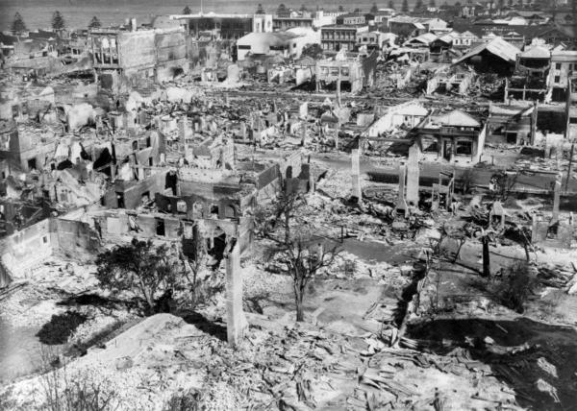
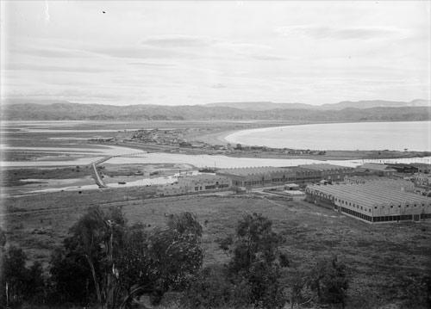
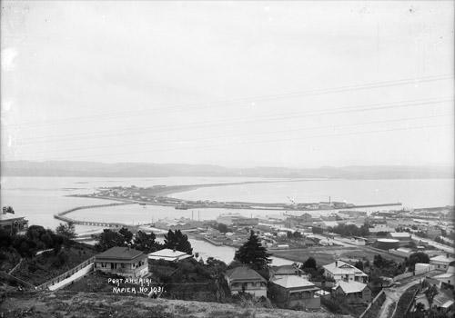
The was the most strongest earthquake to hit a populated area in NZ since the 7.8 at Napier in 1931 (photo). (There was a 7.8 quake in Fiordland last year which moved the South Island about a foot closer to Australia.) The biggest earthquake since measurements have been recorded was an 8.5 magnitude quake in 1855 in the lower North Island. NZ has about 14 000 earthquakes a year, though only about 200 are felt and of these only about 10 cause damage. Nana was in the 1931 quake and only just escaped with her life. She was in Wairoa, not Napier, which is about halfway between Napier and Gisborne. She had just walked out of a shop when it crashed to the ground behind her. Also, her grandmother was in a car travelling from Napier to Wairoa when the earthquake hit and a whole mountainside slid down in front of the car! The Napier quake caused extensive damage (photo above) and lifted the then harbour completely out of the water (see the two pictures before/after on the right). (A similar thing happened in Wellington – in the 1855 quake, I think - which raised all the land near the present airport which then was well below sea level). Also in Napier, the cracks in the road were much greater; photos show whole vehicles swallowed up in them. Nice country to live in!!
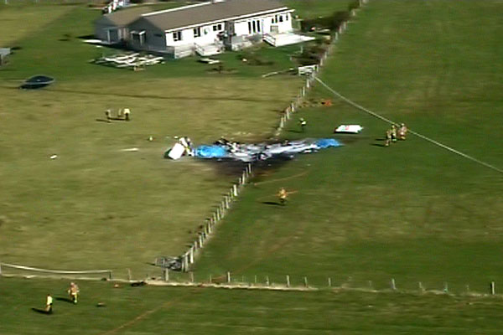
Then also yesterday, there was another tragedy in NZ. A sky-diving plane at Fox Glacier crashed on take-off killing all nine on board – the four instructors and their tandem jumpers together with the pilot. The kind of plane and the situation were exactly the same as when you, Nadine, did your sky diving (though at Wanaka). I happened to see on some TV channel the other night that there have been 39 'adventure' deaths in NZ (and now another 9) in recent years and that things need to be tightened up.
There was a small but interesting clipping in the latest Time magazine about fruits and vegetables in the diet in preventing major diseases. The long-term study it referred to seems to suggest that it is not just the eating of fruits and vegetables per se, but eating a variety that is important, probably as different foods contain different but at present unidentified substances needed for good health. Although the study involved smokers, it is probably relevant to everybody. A few days ago, before reading this clipping, I added up the number of vegetables I was having for dinner and it came to nine! - potato, tofu, carrots, mushrooms, pumpkin, broccoli, beans, and two Chinese vegetables which I don't know the names of. Add to this the lettuce, tomatoes, cucumber I always include in my lunch sandwiches (which includes wheat for the bread) plus the celery (and again carrots) I eat as snacks during the day and it comes to a total of 14 kinds of vegetables – quite a variety! (However, this is probably the maximum I would have.)
Yesterday, in Rugby, Australia beat SA in SA 41-39 with an injury time penalty. So for this year's Tri-Nations, SA have ended up bottom. Still one more game, between Aus and NZ.
That seems to be it for now.
Cheers

